

**CHRIST PORTAL**

By

Anuj Solanki (20218411)

Abhishek (20218402)

**Under the guidance of**

(Mr. IYYAPPAN M)

**Christ Portal** project report submitted in partial

fulfilment of the requirements of IV semester BCA

Christ (Deemed to be University)

Delhi-NCR, India.

March - 2022

**CERTIFICATE**

*This is to certify that the report titled* ***Christ Portal*** *is a bonafide record of work done by* ***Anuj Solanki (20218411), Abhishek (20218402)*** *of* ***Christ (Deemed to be University)*,** *Delhi - NCR. Ghaziabad, India.*

*In partial fulfilment of the requirements of IV Semester BCA during the year 2022.*

**Head of the Department** - *Dr. Shoney Sebastian* **Project Guide –** Dr.*Iyyappan m*

**Valued by -**

|  |  |
| --- | --- |
| **Name:** |  |
| **Registration Number:** |  |
| **Date of Exam:** |  |
| **Examination Centre:** | **Christ (Deemed to be University) Delhi- NCR** |

**Table Of Contents**

**Acknowledgements**

**Abstract**

**List of Tables**

**List of figures**

1. Introduction 1

1.1 Overview of the system

2. System Analysis

2.1 Functional Requirements

2.2 System Requirements

2.2.1 User Characteristics

2.2.2 Software Requirements

2.2.3 Hardware Requirements

2.3 Language Requirements

2.4 Proposed System

2.4.1 Benefits of Proposed System

3. System Design

3.1 Capability Map

3.2 Block Diagram

3.3 Database Design

3.4 ER Diagram

3.5 Data Flow Diagram

3.6 State Transition Diagram

3.7 User Interface Design

4. Implementation

4.1 Source Code

4.2 Screen Shots

5. Testing

5.1 Test Strategies

5.2 Test Cases and Reports

6. Conclusion

**References**

**Acknowledgements**

Date: 23-04-2022

We would like to express our profound gratitude to Dr. Shoney Sebastian (Head of department of computational science) and Rev. Fr. Viju P D (Dean and Director) of Christ University Delhi NCR for giving us opportunity to work on this project titled

Christ Student and Teacher portal.We would like to express our special thanks to our Guide Dr. Iyyappan M for his time and efforts he provided throughout the semester. Your useful advice and suggestions were really helpful to us during the project’s completion. In this aspect, we are eternally grateful to you.

Finally, we would want to convey our sincere thanks to our friends and supporters; without them, the project would not have been accomplished in such a timely manner.

Anuj Solanki

Abhishek Verma

**Abstract**

In this pandemic we have seen the importance of online education and during the online classes we have observed that in the Christ assignments in the most important part that has a 50% weightage in a semester itself. Project does include those modules which are currently not present in Christ knowledge pro; this web application allows student and teacher both to access their portals where they will have access to different modules.

**INTRODUCTION**

* 1. **Overview of the System**

This Web Application will provide the access to the user (Student/teacher). This project does include those modules which are currently not present in Christ knowledge pro, this web application allows student and teacher both to access their portals where they will have access to different modules.Single website with two different experiences for teachers and students. The teacher will be able to perform the following tasks such as adding new assignments, removing assignments, give marks to students for the submitted assignment. Students will be able to perform the following tasks such as submit/unsubmit assignments and check their reports for assignments with different filters (Pending, Upcoming, Submitted). One signup page is designed which will have a user type picklist (Student, Teacher). This user type value will drive two different user experiences as per the logged-in user. One login page will be designed. The teacher portal will have tabs such as Assignments, Report, Student Portal Access, and My Profile. Similarly, the student portal will have tabs such as Assignments, Report, and My Profile. This project provides way solutions to students and teachers for assignments. In the future, I can integrate my web application to the Christ portal or backend so that I can provide authentication with the real data. Instead of saving assignments related documents to any database, we can point those assignments to Google Classroom APIs.

1. **SYSTEM ANALYSIS AND REQUIREMENTS**

**2.1) Functional Requirements:**

Details of the user will be taken and will store inside the database. Based on those details login will be provided to the valid user(teacher/Student) and it will redirect user to the main portal else unregistered user may Signup through Signup page.

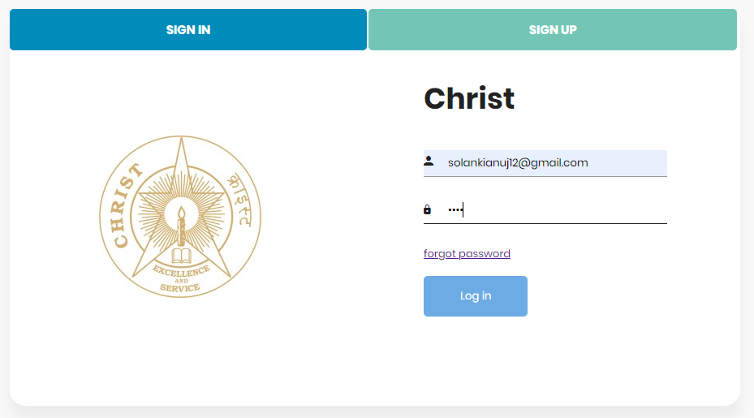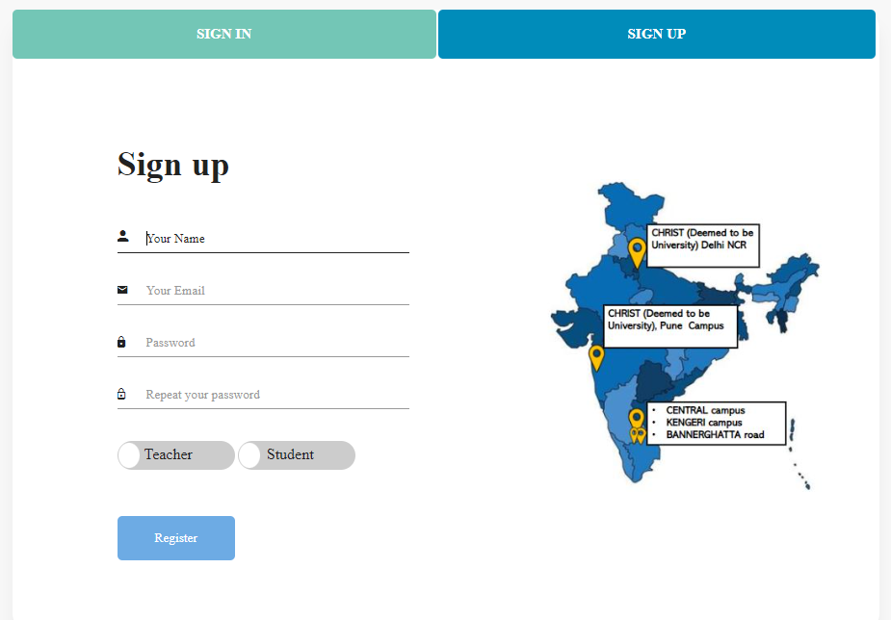

**2.2) System Requirements:**

**2.2.1 User Characteristics:**

i). Students of the university.

ii). Teachers.

**2.2.2 Software Requirements:**

i). Operating System – Windows.

ii). IDE – Eclipse, IntelliJ

iii). Server- Apache Tomcat.

iv). Libraries – JAVA, jQuery, Bootstrap, Google Material UI.

v). Database Server- MySQL.

**2.2.3 Hardware Requirements:**

i). 1.6 Ghz or faster (Recommended).

ii). 4gb ram (Recommended).

iii) Storage 1Gb (Recommended).

**2.3 Language Requirements:**

**i) Tools/Platform:** MySQL Workbench, Eclipse, Visual Studio Code/IntelliJ.

**ii) Backend:** Core Java, JDBC, JavaScript, JSP/Servlet, Apache Tomcat.

**ii) Frontend:** Bootstrap/Google Material UI, CSS, HTML.

**2.4) Proposed System**

**2.4.1 Benefits of Proposed System**

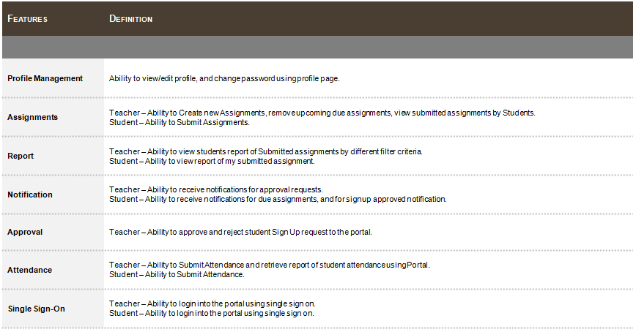

**Module Description:**

**1) Sign-up:** Details will be taken from Teacher/Student then it will be saved to the database.

**2) Sign In:** After signing up a user name and password will be generated on the bases of that user will be able to sign in.

**3) Assignments:** Assignment's list and actions on assignment page will be displayed on basis of logged in user. For instance, if teacher login into the system and click on Assignment's tab, he/she will be able to see Add Assignment Button and Remove Assignment button and will have privilege to modify assignments. Wherein, if student's login they will have access to see assignments but they won’t have Add Assignment and Remove Assignment buttons visibility. Students would be able to submit their own assignments.

**4) Reports:** Students and Teachers can see reports related to assignments.

**5) Approval Request:** Teacher will have access to this page where he can approve or reject student access on portal. When student fill out signup page with their details one request will be created in Teacher Portal under Approval Request. Once request gets approved then only student will be able to sign in into the portal using sign in page.

**6) My Profile:** Students and Teachers can update their profile image and their details.

1. **SYSTEM DESIGN**

**3.1 Capability Map**

**student portal**

Profile Management

Assignments

Report

Notifications

Submit Attendance

Single-Sign On

Google Classroom Sync

teacher **portal**

Profile Management

Assignments

Report

Notifications

Approval

Attendance Report

Single-Sign On

Google Classroom Sync

**KEY**

MVP

Future

Category

Fig.3.1: Capability Map

**3.2 Block Flow Diagram**

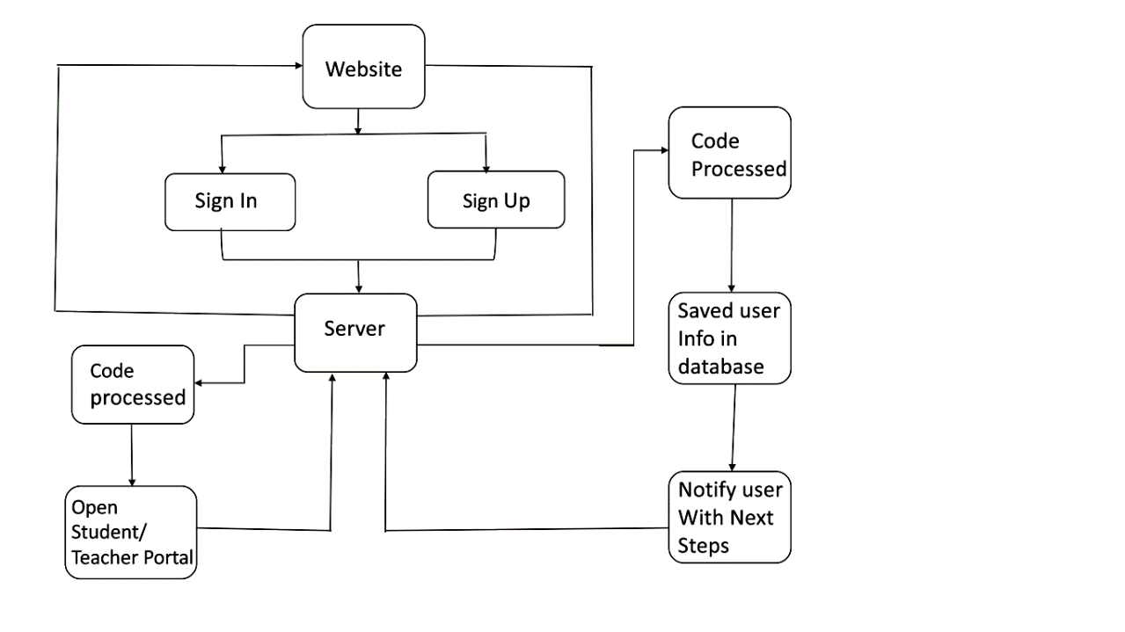

Fig.3.2: Block Flow Diagram

In this block diagram when the user visits the website, there will be two options (Sign-In) and (Sign-Up). If the details of the user are saved inside the database and the user is valid then through (Sign-In) a request will be sent to the server to access the portal and after receiving the request server responds and open the portal. And if the user is unregistered then through the (Sign-Up) page request will be sent to the server to save the user details inside the database.

**3.3 Database Design**

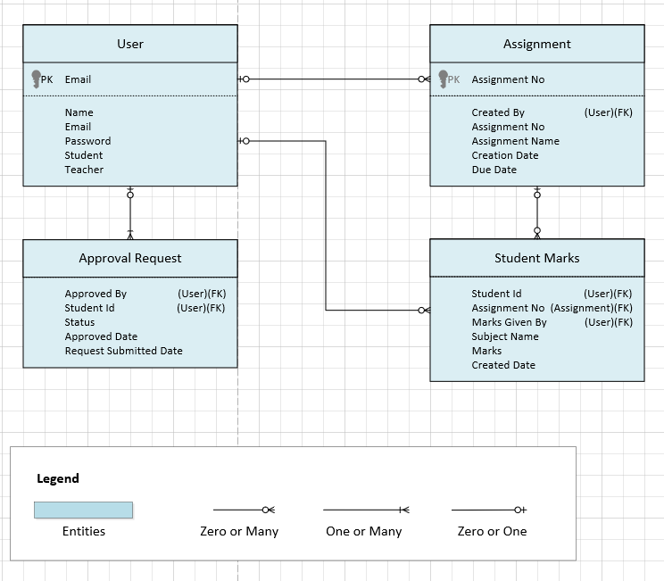

Fig.3.3: Database Design

**(Tables Design)**

1. **User Table**

1. **Assignments Table**

1. **Approval Request Table**

1. **Student Marks**

**3.4 ER Diagram**

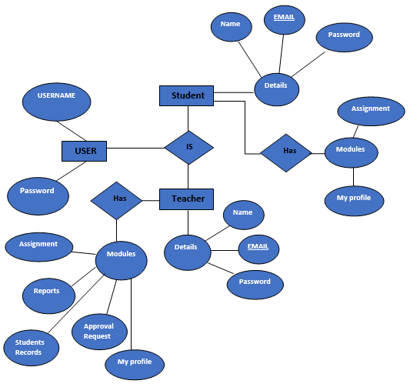

Fig.3.4: ER Diagram

In this ER (Entity Relationship) Diagram, there are Entities (User, Student, Teacher) where the user has two attributes, "username and Password" and the teacher has some modules Assignment, Reports, Student Records, Approval Request, and My profile. The teacher has attribute Details in which attributes are (Name, Email, Password). The student has modules Assignment, my profile and the student has composite attribute details where attributes are (Name, Email, Password).

**3.5 Data Flow Diagram(0-level)**

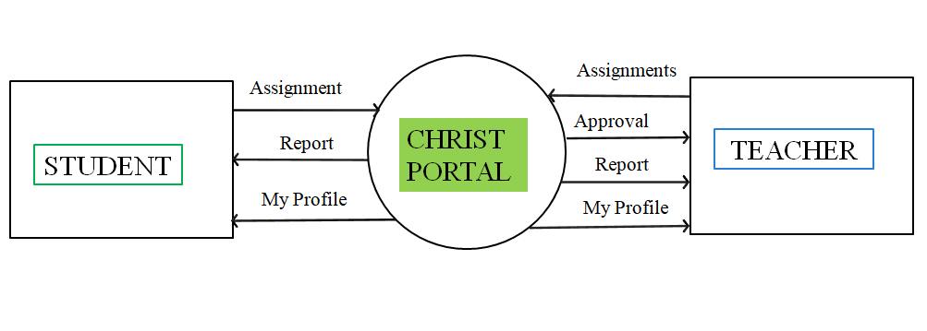

Fig.3.5: Data Flow Diagram (0 level)

In this data flow diagram, Students can see reports and profiles and can submit the assignment and the teacher can approve the request raised by the students to access the portal. The teacher can access the (reports and profile) and can create the assignments.

**3.5 State Transition Diagram**

1. **(Sign-In)**

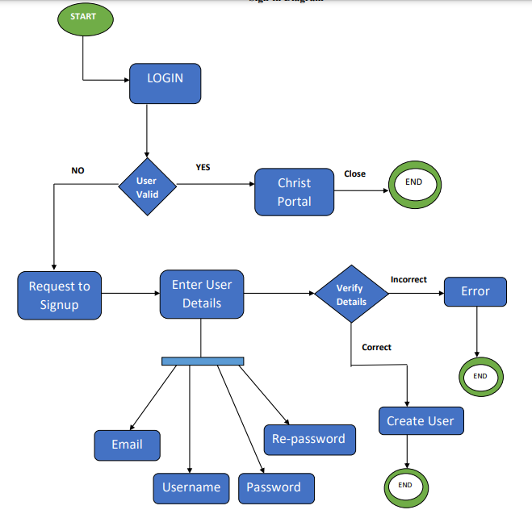

Fig.3.5. i: State Transition Diagram (Sign-In)

1. **(Sign-Up)**

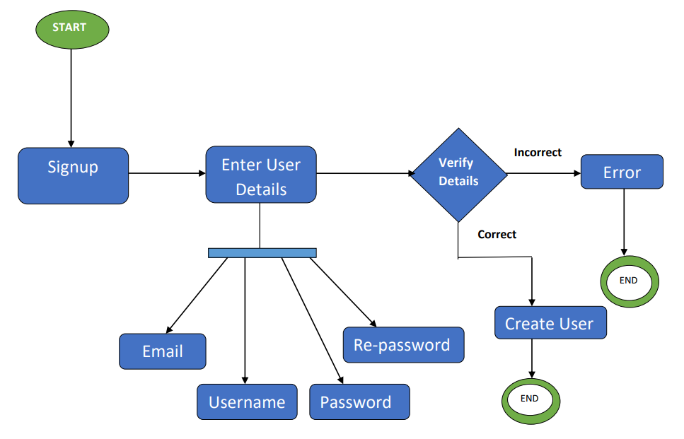

Fig.3.5. ii: State Transition Diagram (Sign-Up)

**3.6 User Interface Design (UI)**

1. **LOG-IN:**

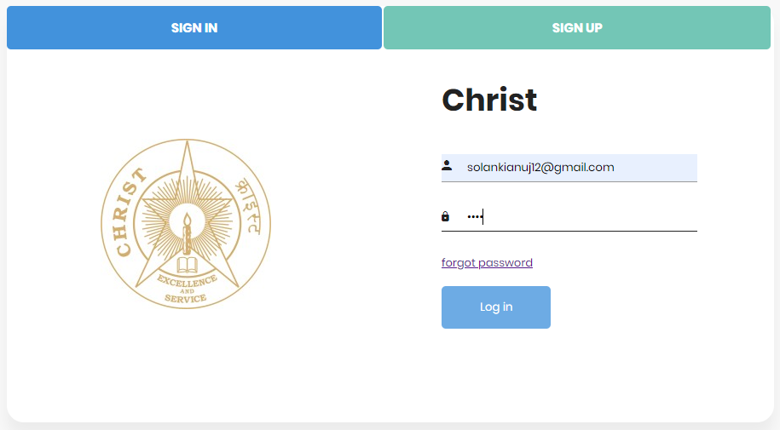

1. **SIGN-UP**

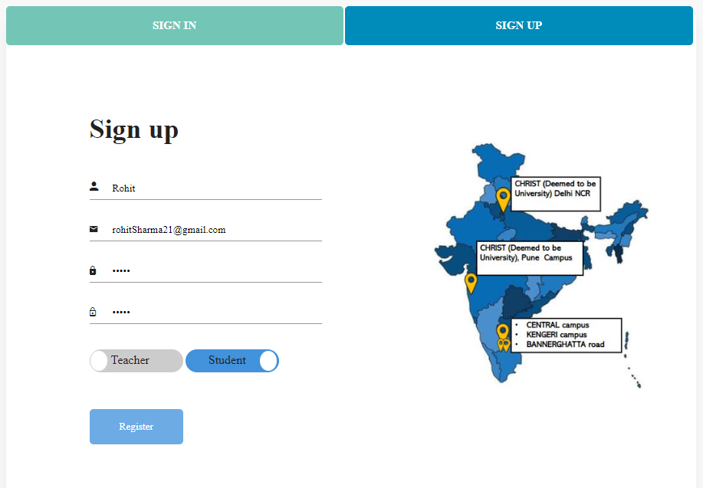

1. **PORTAL**

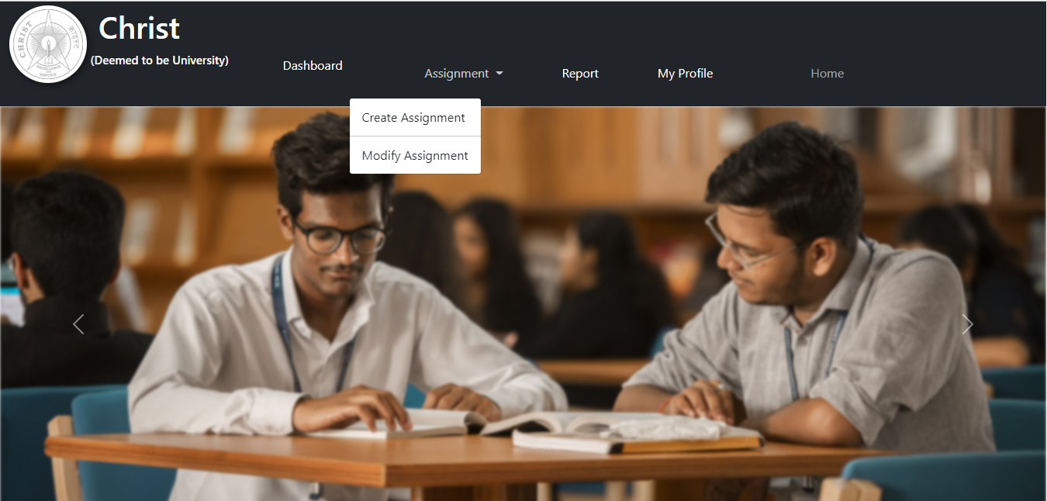

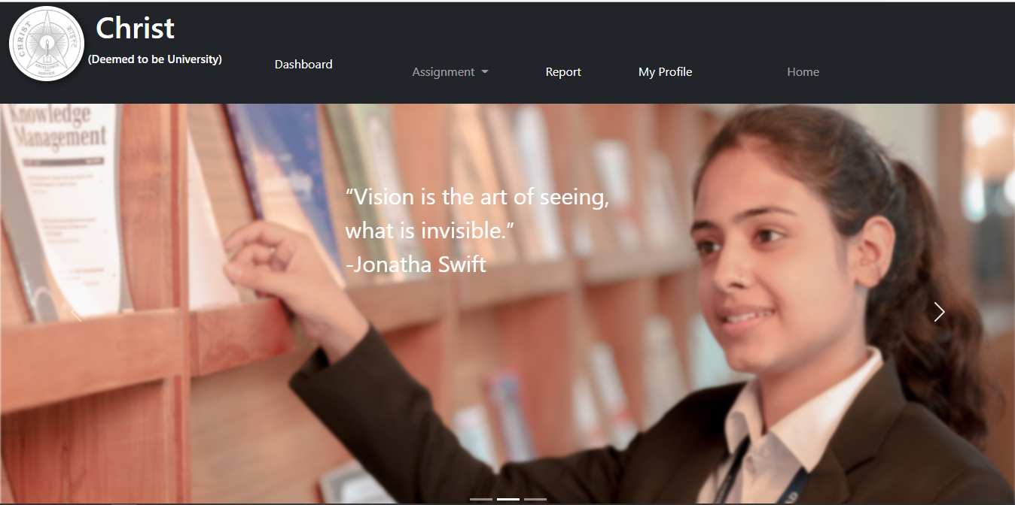

1. **CREATE ASSIGNMENT**

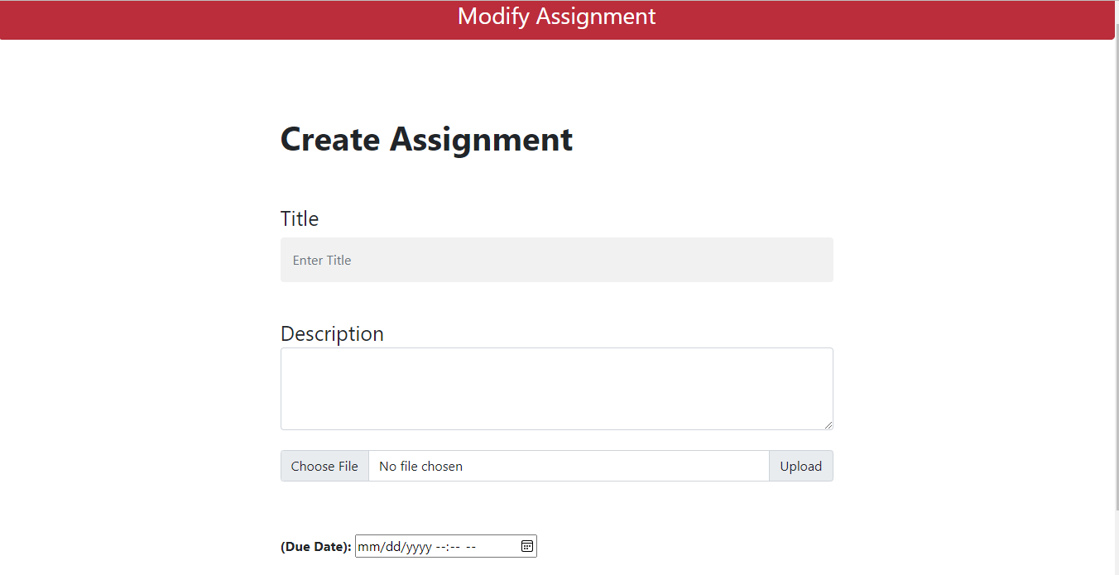

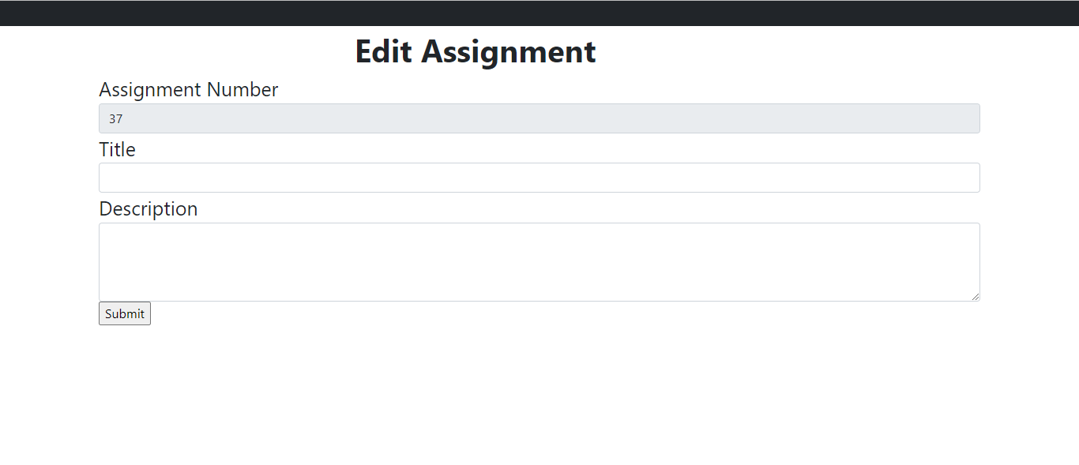

1. **TEACHER DASHBOARD**

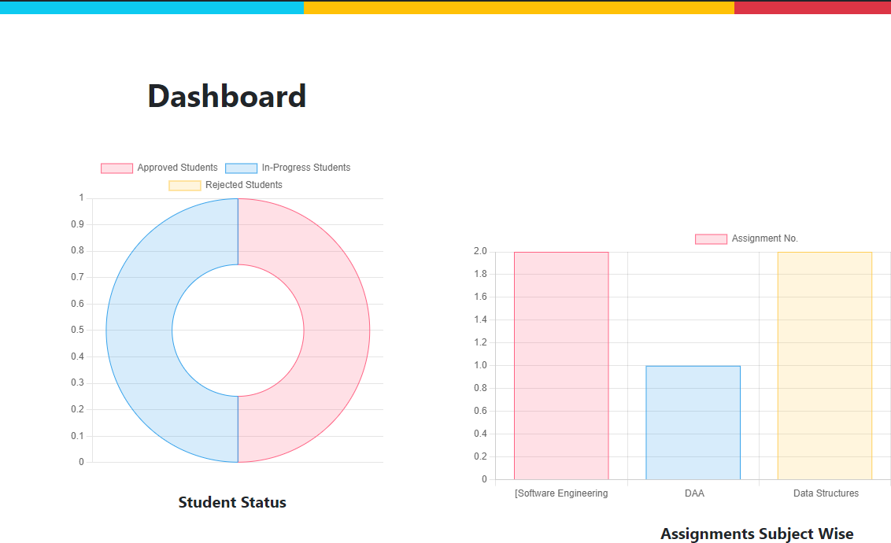

1. **REPORT PAGE**

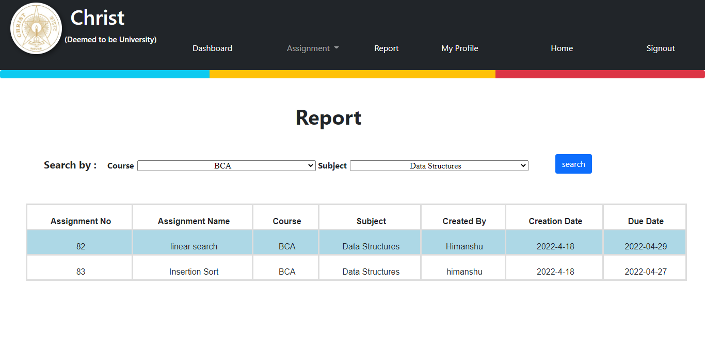

1. **MY PROFILE**

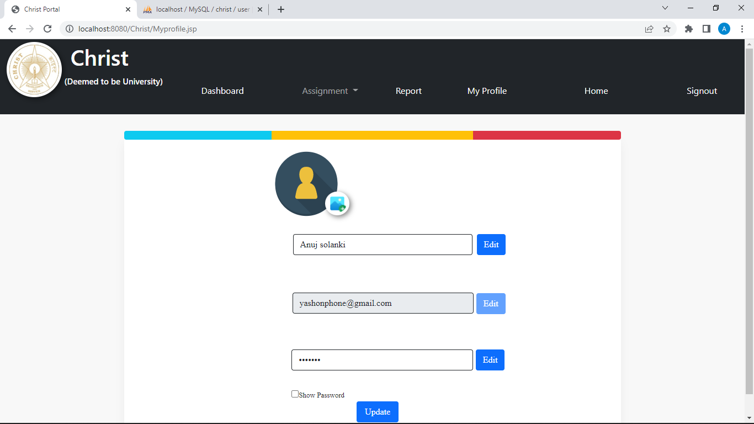

1. **MODIFY ASSIGNMENT**

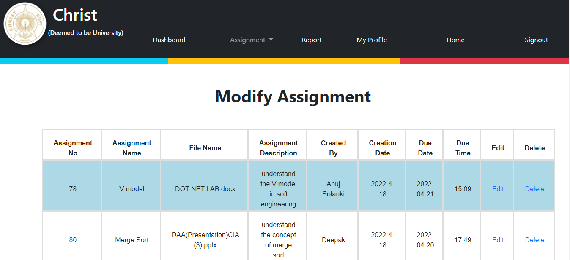

**4. Implementation**

**4.1 Source Code**

1. **(INDEX.JSP)** file the first page of the website that will load and will fetch the stored details of the user from the database and that will be checked with the details entered by the user to provide success login.

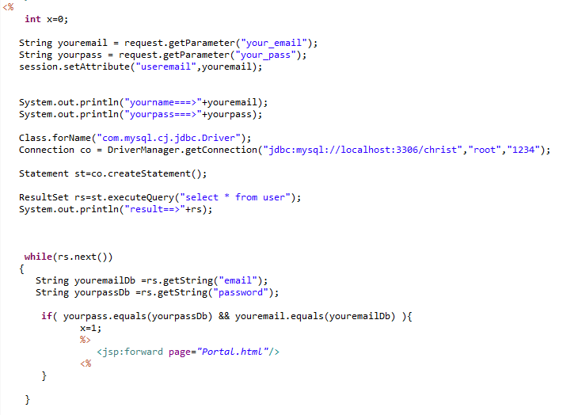

1. **(SIGNUP.JSP)**file to register the user details inside the database. There are two toggle buttons based on which it will be identified whether the user is a teacher or a student.

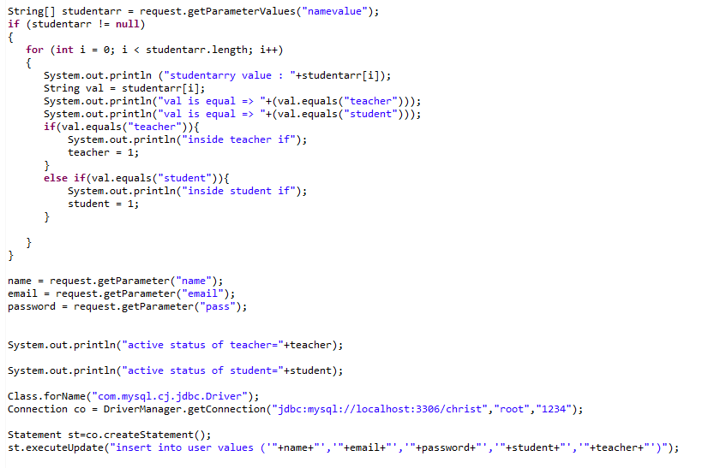

1. **(CREATE ASSIGNMENT.JSP)** file is used tocreate the assignment.

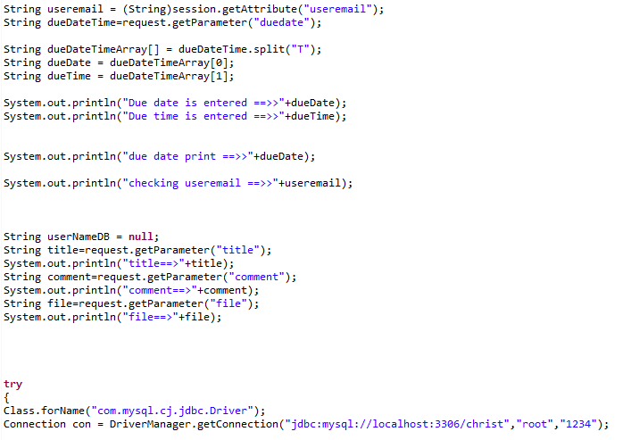

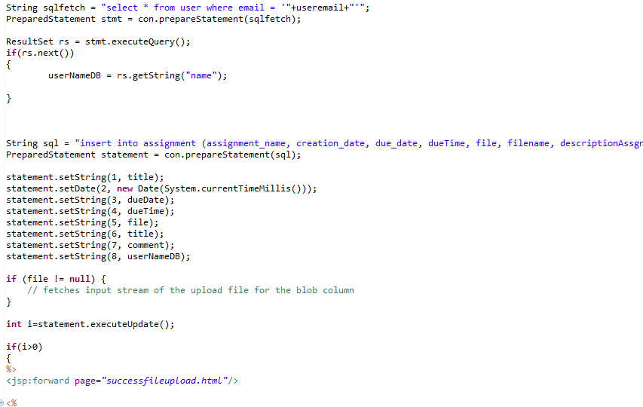

1. **(MODIFY ASSIGNMENT.JSP)** file is used to modify the details of the assignment in the database.

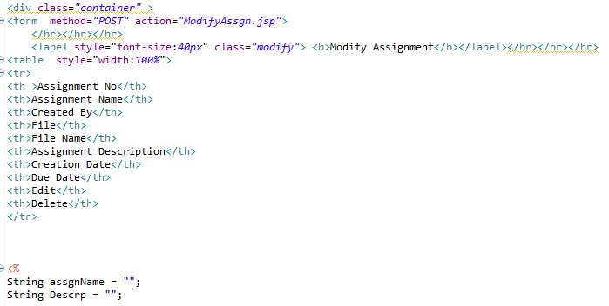

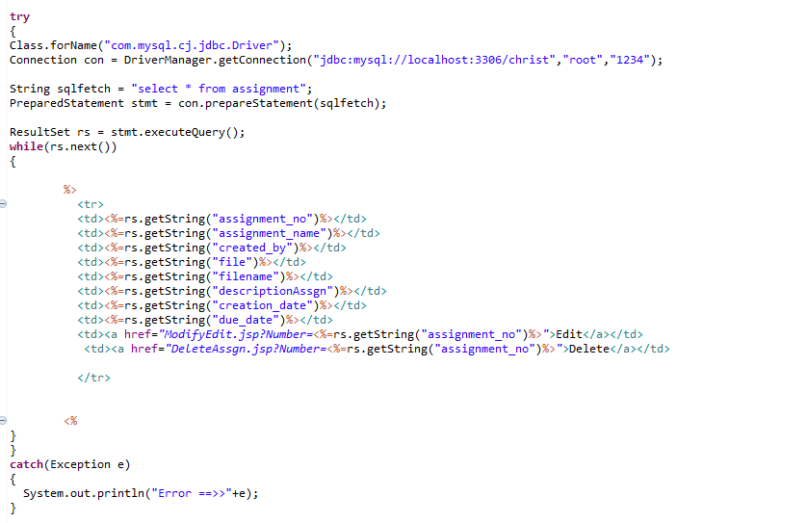

1. **(ADMIN REPORT CODE)** to check the requests of the users.

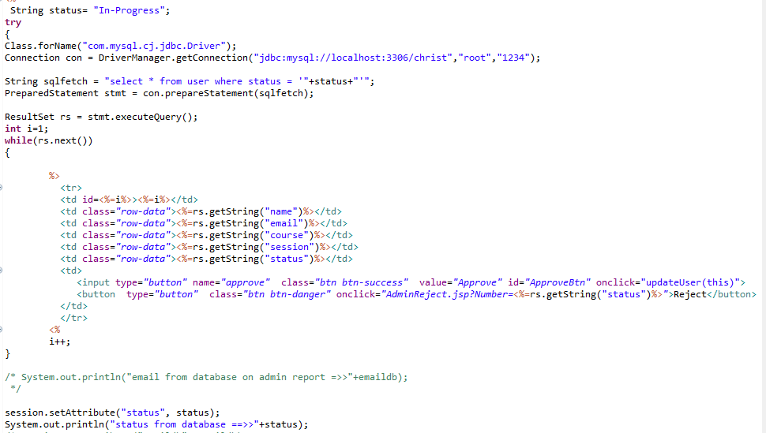

1. **(Teacher Dashboard)** to check the request status and assignment status in graphical form

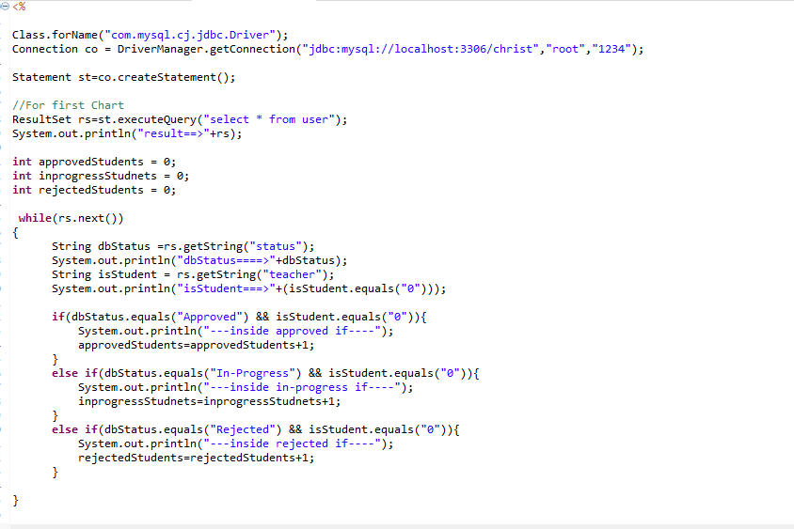

1. **(TEACHER PORTAL REPORT)** to check the status of assignments submitted based on the filter conditions.

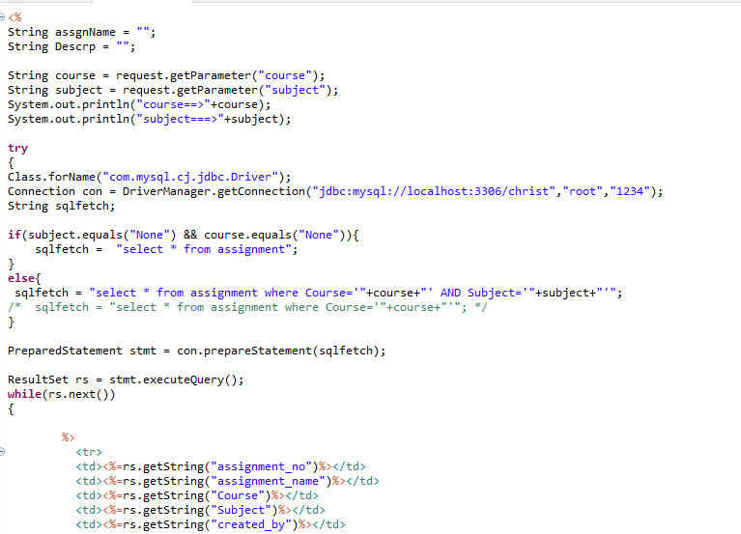

1. **STUDENT PORTAL ASSIGNMENT VIEW**

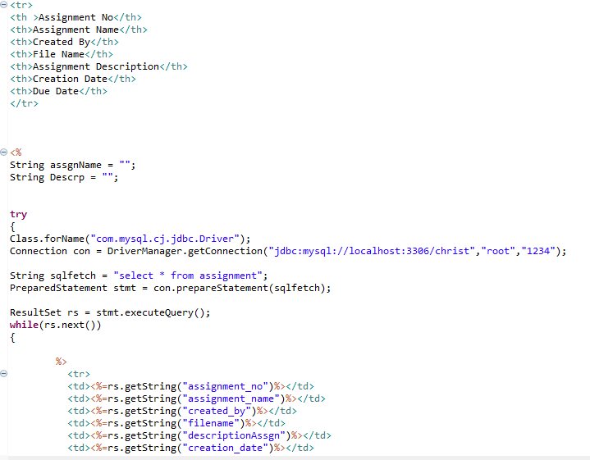

1. **STUDENT PORTAL MODIFY ASSIGNMENT**

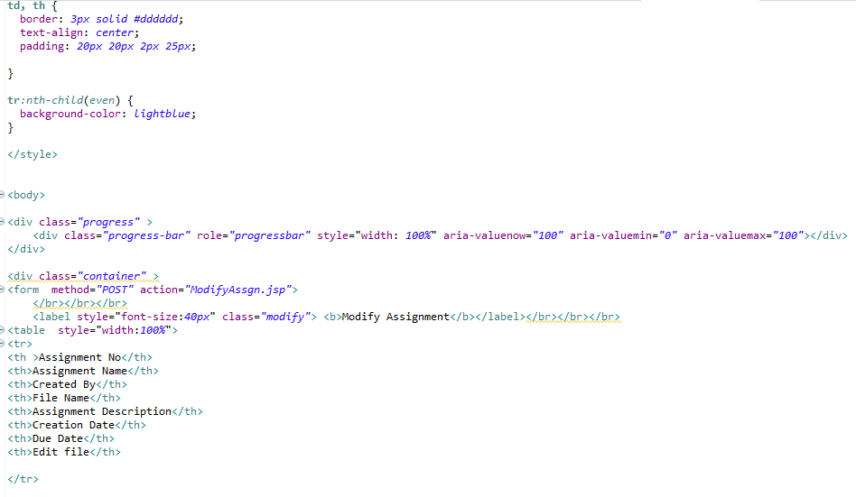

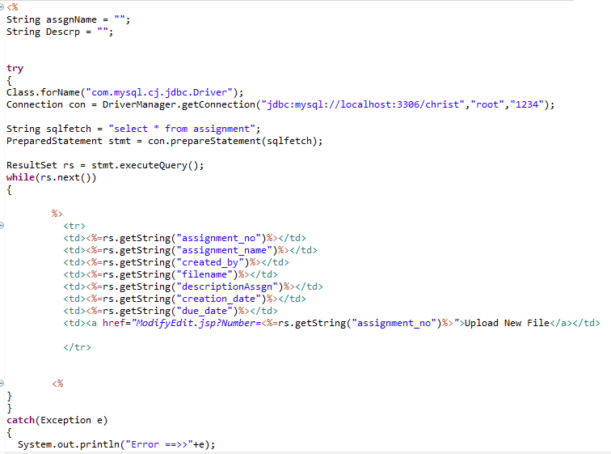

1. **TEACHER PORTAL DELETE ASSIGNMENT**

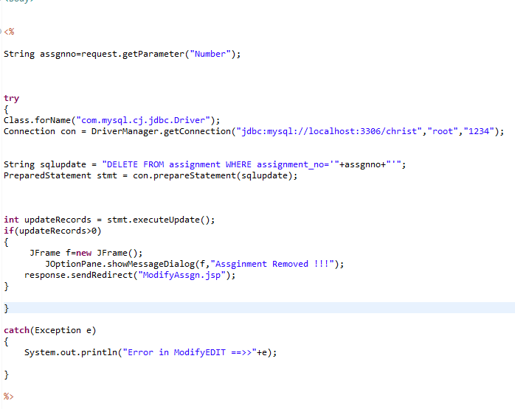

1. **(EMAIL TRIGER)** to send mail after assignment creation

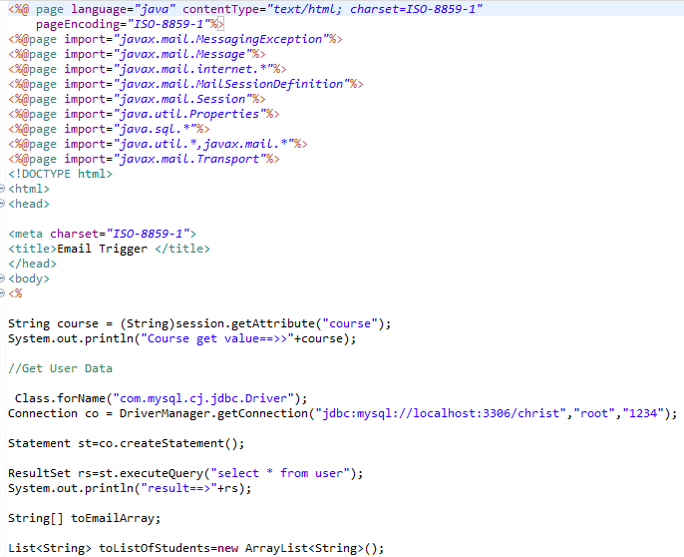

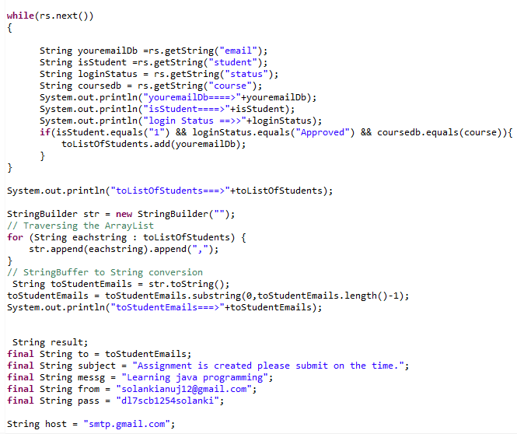

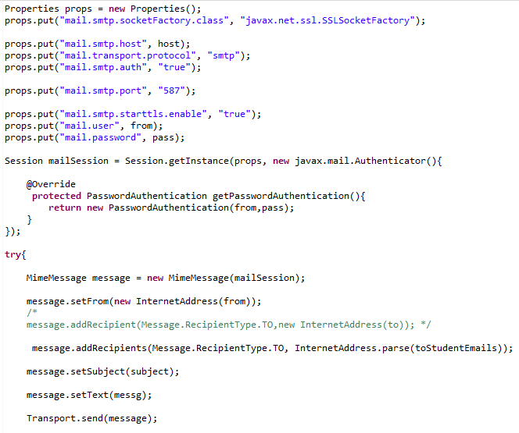

1. **(OTP CONFIRMATION)** to update the my profile

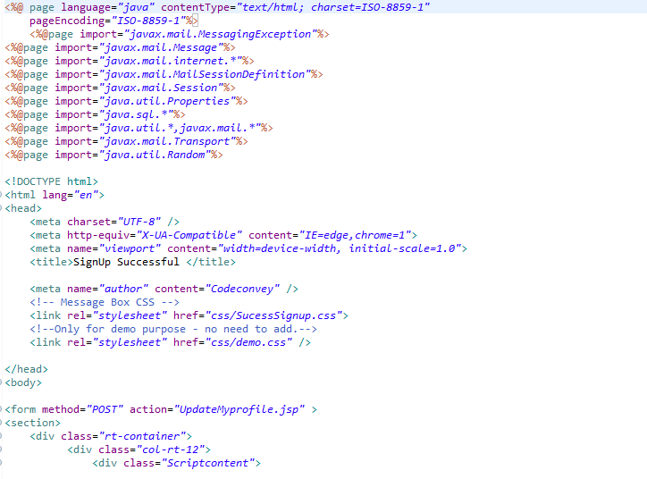

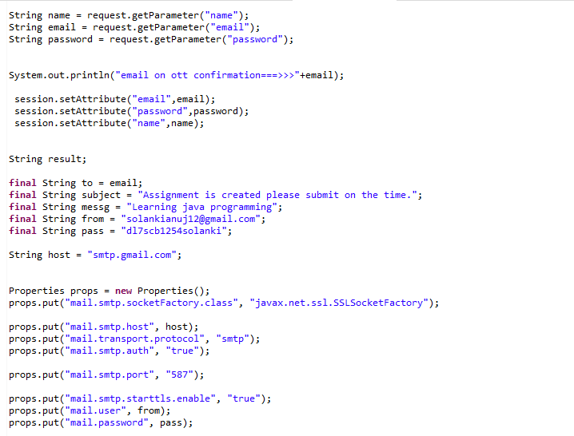

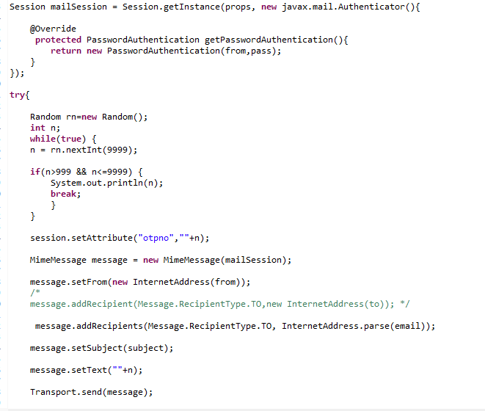

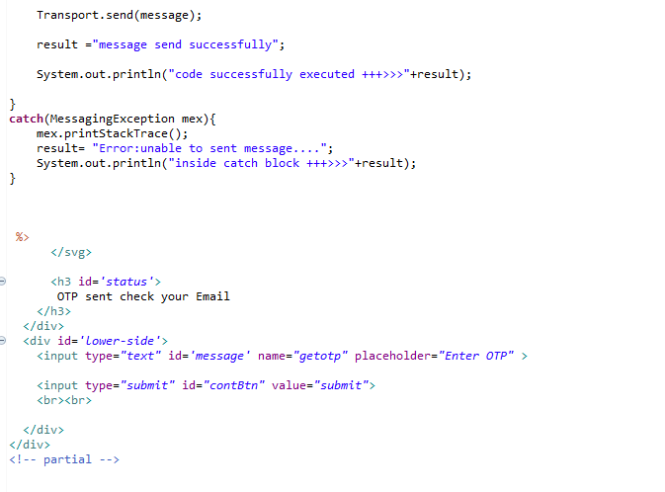

1. **Testing**

**5.1 Test Strategies**

* + 1. Unit Testing
    2. Integration Testing

**5.2 Test Cases and Reports**

Step 1: Login to the portal

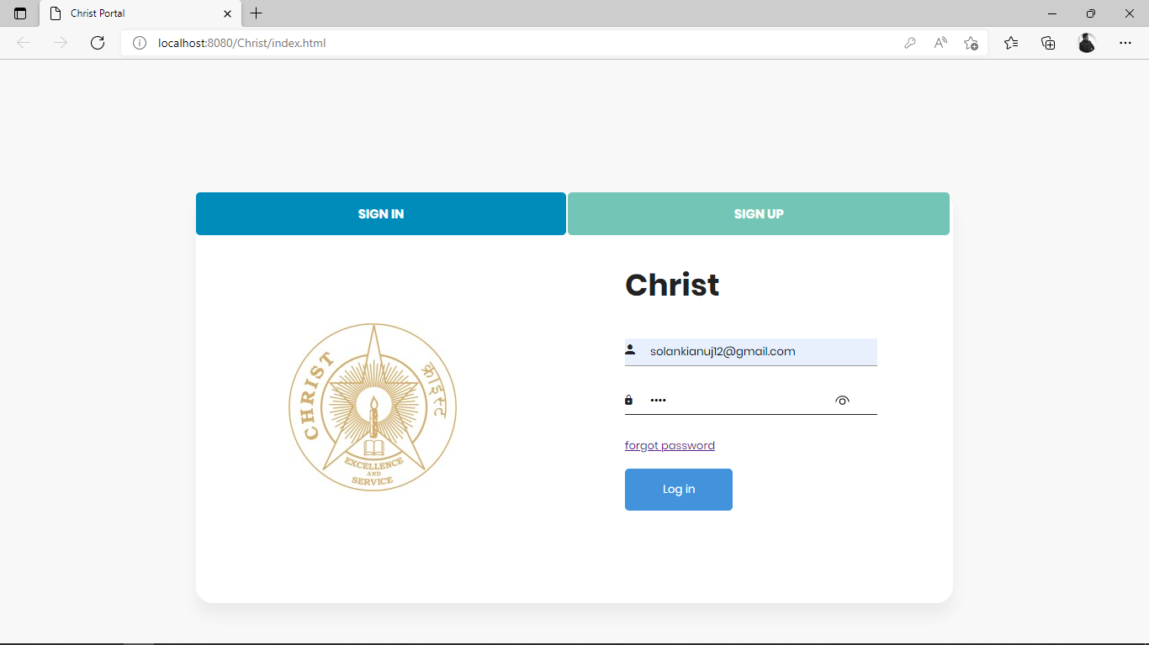

Login successful to the Portal

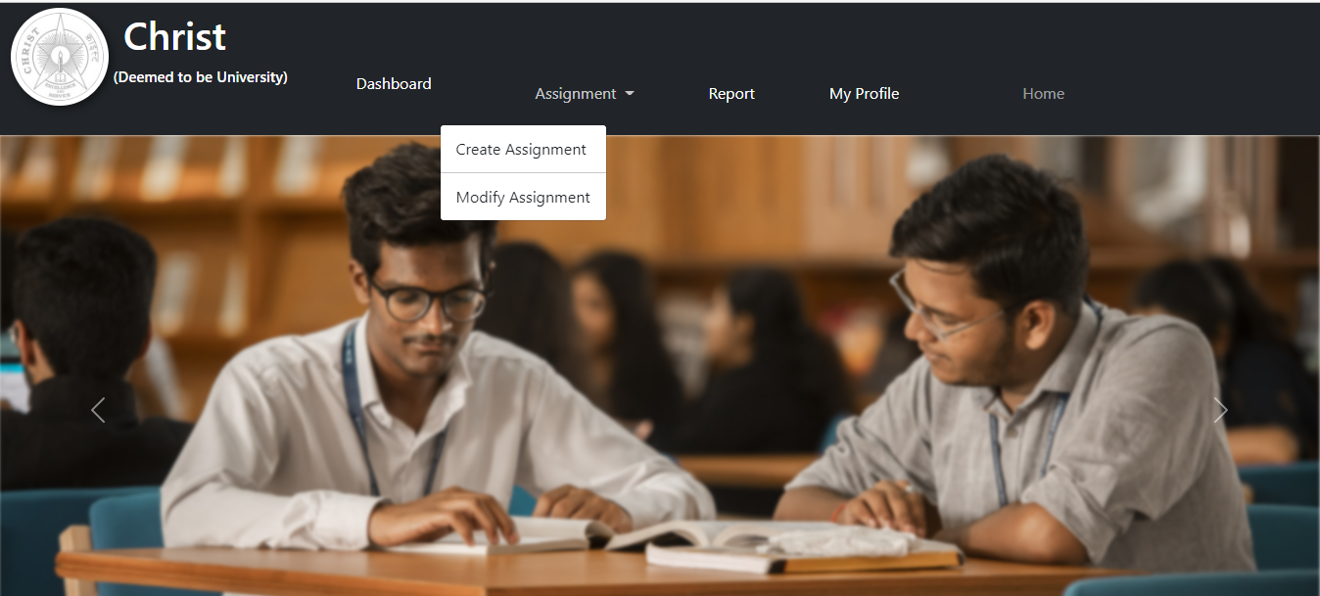

Step 2: Assignment Creation

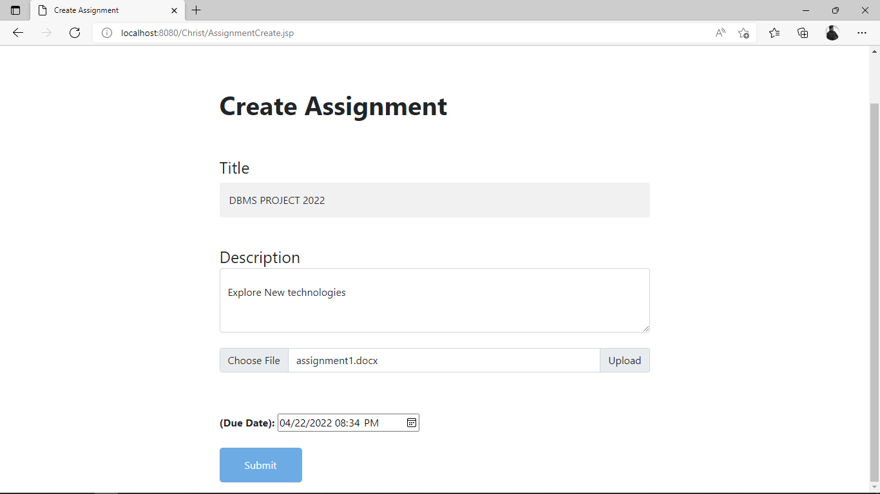

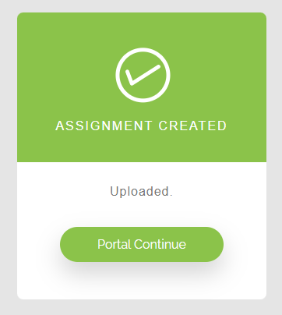

Step 3: Assignment Modification

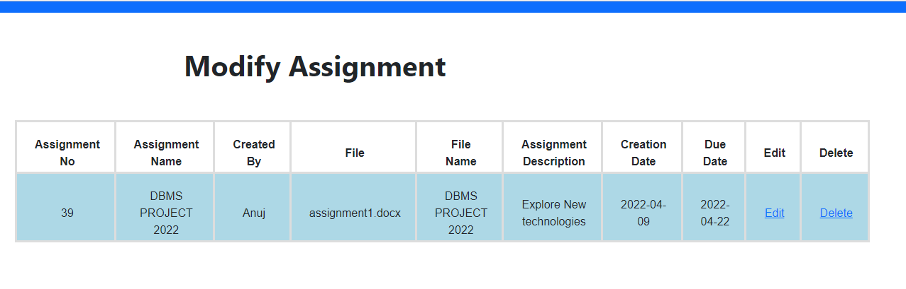

**Edit Assignment**

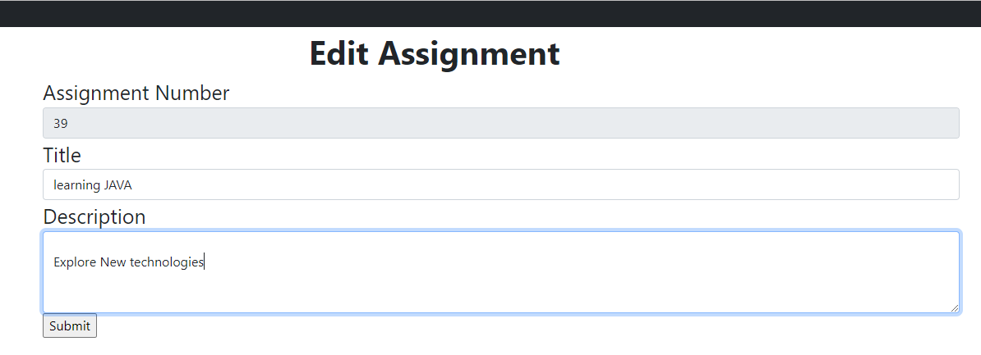

Assignment successfully modified.

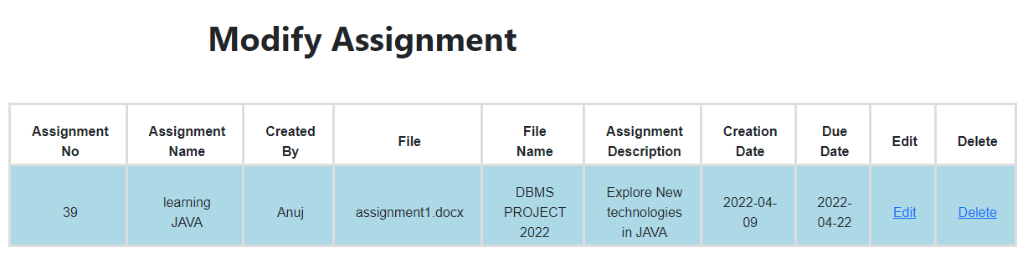

1. **Conclusion**

In this project a single website with two different experiences for teachers and students. The teacher will be able to perform the following tasks such as adding new assignments, removing assignments, give marks to students for the submitted assignment. Students will be able to perform the following tasks such as submit/unsubmit assignments and check their reports for assignments with different filters (Pending, Upcoming, Submitted). In the future, I can integrate my web application to the Christ portal or backend so that I can provide authentication with the real data. Instead of saving assignments related documents to any database, we can point those assignments to Google Classroom APIs.

**Referencing**

**Online:**

[**https://www.javatpoint.com/**](https://www.javatpoint.com/)

[**https://www.w3schools.com/**](https://www.w3schools.com/)

[**https://www.geeksforgeeks.org/**](https://www.geeksforgeeks.org/)

[**https://www.visual-paradigm.com/**](https://www.visual-paradigm.com/)

**Books:**

[1] Bates, Bert and Sierra, Kathy. Head First Java. O’Reilly Media, Inc, 2003

[2] Schildt, Herbert. The Complete Reference Java Seventh Edition. Sai Shouri,1 July 2017

[3] Kumar, Rohit. Java Standard Edition. City: Delhi, Cetpa.